I Am A Leader When…

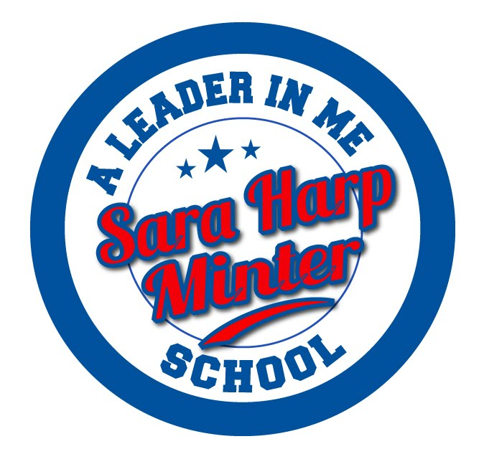 | Hallway  Silent Zone | Playground | Cafe | Bathroom  Quiet Zone | Technology | Assembly | Media
I am RESPECTFUL. | Hands to self.  Be Polite. | Take turns.  Use your words. | Use Minter Manners.  Respect personal space. | Respect the privacy of others.  Use kind words. | Participate  appropriately.  Be a positive role model of digital citizenship. | Participate appropriately.  Be an active listener. | Participate appropriately.  Be an active listener.
I am RESPONSIBLE. | Follow directions.  Walk directly to destination. | Follow directions.  Clean up after yourself. | Follow directions.  Clean up after yourself. | Keep bathroom clean.  Go, Flush, Wash, Leave | Follow directions.  Be a digital citizen. | Follow directions.  Stay seated. | Follow directions.  Clean up after yourself.
I am SAFE. | Be alert.  Eyes forward. | Stay in assigned area.  Use equipment properly. | Eat only your food.  Stay in your seat. | Report problems to an adult.  Keep your body to yourself. | Report misuse to an adult.  Visit only approved sites. | Keep your body to yourself.  Be calm. | Be calm.  Share space with others.
I am a PROBLEM SOLVER. | Get to where you are going with a purpose.  Walk away from teasing situations or use STOP, WALK, TALK. | Walk away from teasing situations or use STOP, WALK, TALK.  Count to 10 if you get angry. | Inform an adult of dangerous or teasing situations.  Count to 10 if you get angry. | Report any misbehavior to a teacher/adult right away. | Think or a possible solution before speaking to your teacher.  Use only teacher assigned Websites. | Ignore misbehavior and model positive behavior for the students around you. | Report any misbehavior to the teacher.  Listen and follow all directions in the media center.

